INDIAN INSTITUTE OF SCIENCE EDUCATION AND RESEARCH




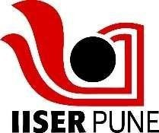
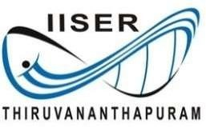
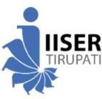
Admission to BS-MS Dual Degree/BS Degree/B. Tech Degree Program 2026

Medical Examination Report
(To be issued by a Registered Medical Practitioner)
1. | Application Number: |  | Paste your recent passport- size  photograph here
2. | Category (GE, OBC, OBC-NCL, SC, ST, EWS, KM): |  | Paste your recent passport- size  photograph here
3. | PwD (Yes / No): |  | Paste your recent passport- size  photograph here
4. | Name of the Candidate: |  | Paste your recent passport- size  photograph here
5. | Date of Birth: |  | Paste your recent passport- size  photograph here
6. | Gender:
7. | Identification Mark:
8. | Major Illness, if any:
Medical Certificate
(To be filled by the Medical Officer Conducting the Test)
1. | Height:
2. | Weight:
3. | Past History | Mental Diseases:
3. | Past History | Epileptic fits:
4. | Chest | Inspiration:
4. | Chest | Expiration:
5. | Blood Group:
6. | Hearing:
7. | Vision  (with or without glasses) | Right Eye:
 | Vision  (with or without glasses) | Left Eye:
 | Vision  (with or without glasses) | Color Blindness:
8. | Respiratory System:
9. | Nervous System:
10. | Heart | Sounds:
 |  | Murmur:
11. | Abdomen: | Liver:
 |  | Spleen:
12. | Hernia:
13. | Hydrocele:

14. | Any other defects:
Certified that . . . . . . . . . . . . . . . . . . . . . . . . . . . . . . . . . . . . . . . . . . . . . . . .

Son / Daughter of . . . . . . . . . . . . . . . . . . . . . . . . . . . . . . . . . . . . . . . . . . . .

- Fulfills the prescribed standard of physical fitness and is FIT for admission to 5 Year BS-MS Dual Degree or 4 Year B.Tech. Degree or 4 Year BS Degree Program 2026.
- Does not fulfill the prescribed standard of physical fitness and is unfit/temporarily unfit
for admission due to following defects

Signature of the Medical Officer  (Minimum Qualification MBBS / MD)  Medical Registration Number: Address:  Official Stamp Date: | Signature of the Candidate

