INDIAN INSTITUTES OF SCIENCE EDUCATION AND RESEARCH
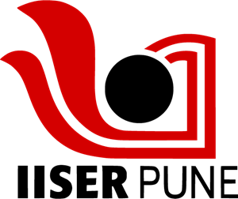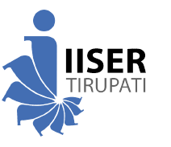
Admission to BS-MS Dual Degree/BS Degree/B. Tech Degree Program 2026
Medical Examination Report
(To be issued by a Registered Medical Practitioner)
1. | Application Number: |  | Paste your  recent passport  size  photograph here
2. | Category (GEN, OBC, OBC-NCL, SC, ST, EWS, KM): |  | Paste your  recent passport  size  photograph here
3. | PwD (Yes / No):  If Yes, Nature of disability: |  | Paste your  recent passport  size  photograph here
4. | Name of the Candidate: |  | Paste your  recent passport  size  photograph here
5. | Date of Birth: |  | Paste your  recent passport  size  photograph here
6. | Gender:
7. | Identification Mark:
8. | Major Illness, if any:
Medical Certificate
(To be filled by the Medical Officer Conducting the Test)
1. | Height:
2. | Weight:
3. | Past History | Mental Diseases:
3. | Past History | Epileptic fits:
4. | Chest | Inspiration:
4. | Chest | Expiration:
5. | Blood Group:

6. | Hearing:
7. | Vision  (with or without  glasses) | Right Eye:
 | Vision  (with or without  glasses) | Left Eye:
 | Vision  (with or without  glasses) | Color Blindness:
8. | Respiratory System:
9. | Nervous System:
10 | Heart | Sounds:
10 |  | Murmur:
11 | Abdomen: | Liver:
11 | Abdomen: | Spleen:
12 | Hernia:
13 | Hydrocele:
14 | Any other defects:
Certified that . . . . . . . . . . . . . . . . . . . . . . . . . . . . . . . . . . . . . . . . . . . . . . . .
Son / Daughter of . . . . . . . . . . . . . . . . . . . . . . . . . . . . . . . . . . . . . . . . . . . .
(a) Fulfills the prescribed standard of physical fitness and is FIT for admission to the 5 Year BS-MS Dual Degree or the 4 Year B.Tech. Degree or 4 Year BS Degree Program 2025.
(b) Does not fulfill the prescribed standard of physical fitness and is unfit/temporarily unfit for admission due to the following defects:


Signature of the Medical Officer
(Minimum Qualification MBBS / MD)
Full Name:
Medical Registration Number:
Address:
Official Stamp
Date: Signature of the Candidate

